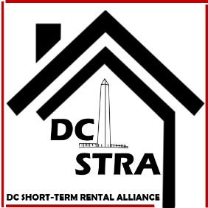

New Poll Finds D.C. Residents Support Short-Term Rentals And Think Current D.C. Bill Hurts Homeowners And Local Businesses
Washington, D.C. – Sixty-one (61) percent of D.C. residents support short-term rentals operating in their communities, a number four times as high as those who oppose them, according to a new poll sponsored by the Chamber Technology Engagement Center, the tech policy hub of the U.S. Chamber of Commerce. The poll also found a majority of D.C. residents believe vacation rentals bring new revenue to cities and help homeowners afford their homes.
"These poll results reinforce the need to oppose Councilmember McDuffie's short-term rental bill, which would eliminate whole-home rentals, and as a result, eliminate the benefits these rentals bring to homeowners, small businesses, and the city overall," said D.C. Short Term Rental Alliance (DCSTRA) Co-Chair Dia Michels. "Instead, we need regulations that protect the value of vacation rentals and reflect the needs of the residents in our community."
The poll, conducted by Morning Consult, surveyed 502 adults from October 5 -17, 2017. Key findings are listed below, and the full poll results can be found here.
- Eighty (80) percent of D.C. residents agree that short-term rentals help D.C. homeowners afford their homes.
- More than sixty (60) percent of D.C. residents believe vacation rentals help the D.C. economy, and sixty-six (66) percent believe they positively impact local businesses that rely on this income.
- Regarding a new bill, adults support requiring a homeowner to register with the city and acquire a new business license. They oppose only allowing a homeowner to rent out a single unit.
- A plurality of respondents agree that the current bill does nothing to address issues of affordable housing within the city. Instead, it hurts homeowners who rely on extra income, as well as local businesses that benefit from tourism.
D.C. City Council is expected to vote on Councilmember McDuffie's proposed short-term rental bill this fall. DCSTRA continues to work with councilmembers to find new policies that will improve enforcement and taxation – two things the alliance has supported from the beginning.
For stories on how this bill would impact vacation rental owners and small business owners in D.C., watch the video we released last month.
###
About DCSTRA
The DC Short-Term Rental Alliance advocates for property rights and supports common sense regulation for short-term and vacation rentals in Washington, D.C.. We value the economic, social, and community benefits that this opportunity presents and want to see the District of Columbia embrace and lead in this growth area.

